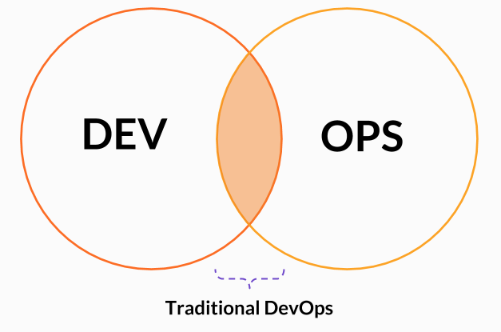

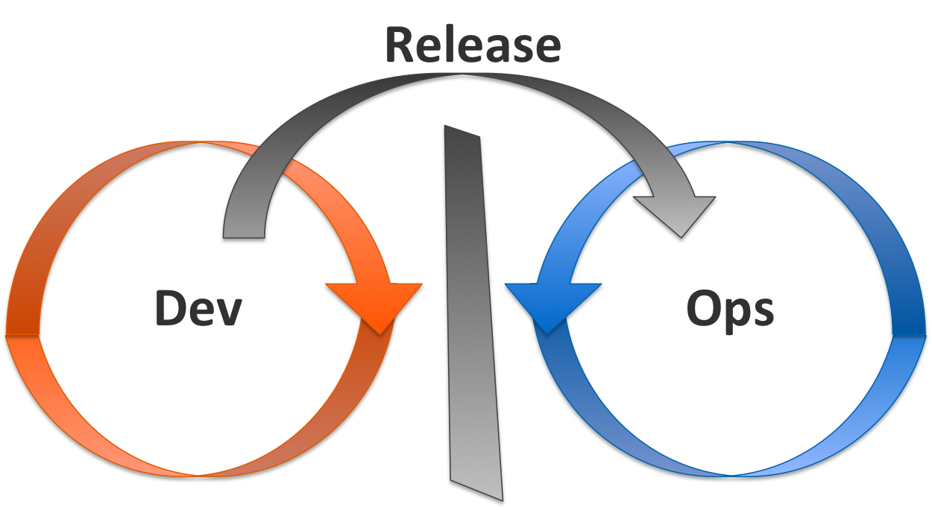

1. Developer commits code 🡪 Operational Team build & host the application.
2. If any errors in build, then code will be sent back to developers & need to resolve or fix the bugs/issues and then again, they need to commit or push the latest code.
3. Once the latest code is available they need to build & release, if same scenario is repeated need to follow up same procedure.
4. This process is burden for both developers, operational team so to resolve this issue we have DevOps.
5. DevOps is the one of the automation process for many thing
6. For CICD
7. For services (Maven, Docker, DB)